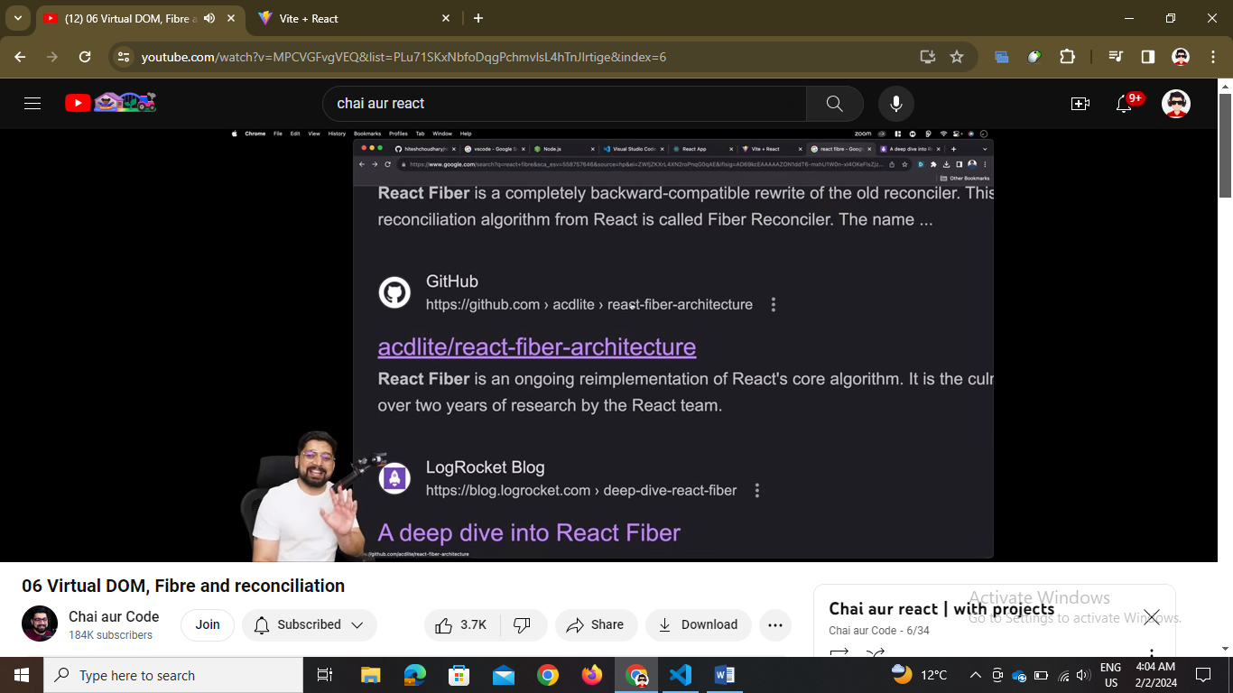

// see this article of github for react fibre algo

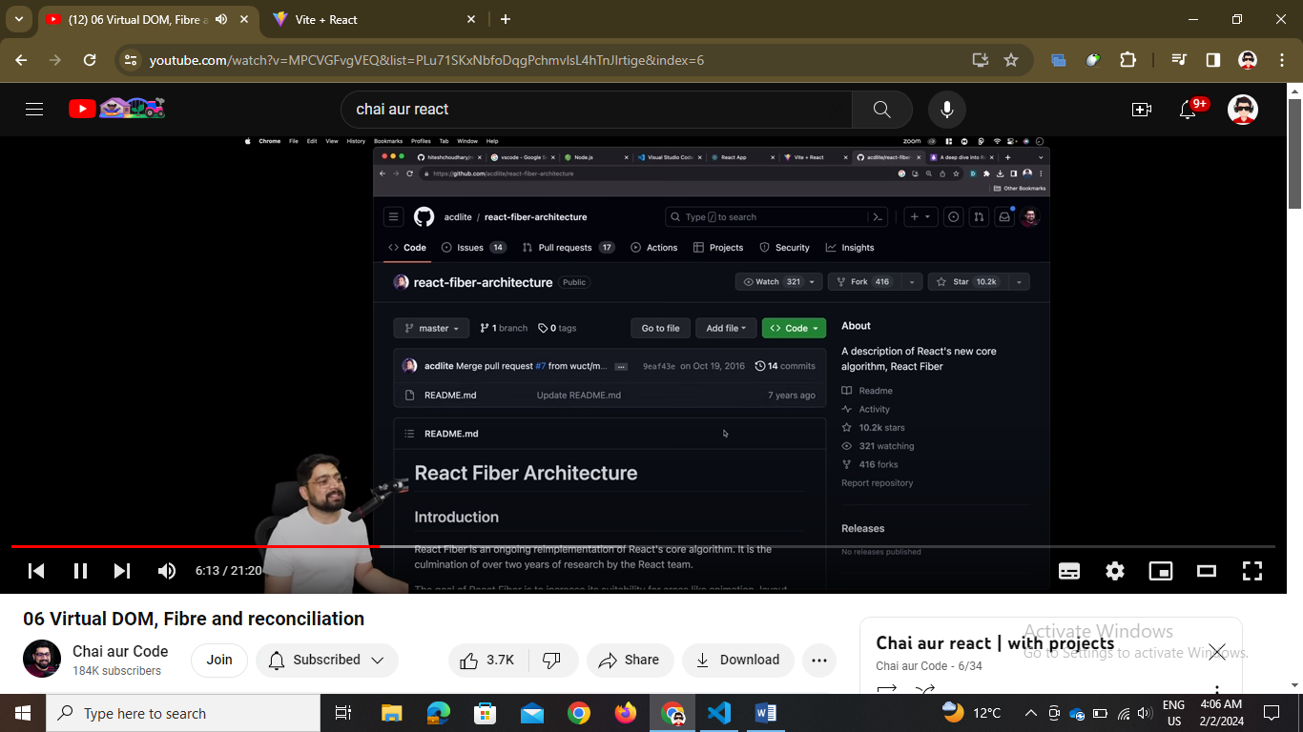

// so virtual dom matlab ek parallel dom jo react banata hai and compare karta hai real dom se and necessary changes hi karta hai bas not all so it prevents page reloading

// hydration is ejecting of js 🡪 that is jab page reload hota hai toh sare components aa jate hai but work nahi karte as js nahi hota so javascript eject hone ko hydration khete hai

// fibre it is a new implemented algo joh react ko unwanted reloads se bachate hai like job hi recent ui call hoyi hai use execute karte hai

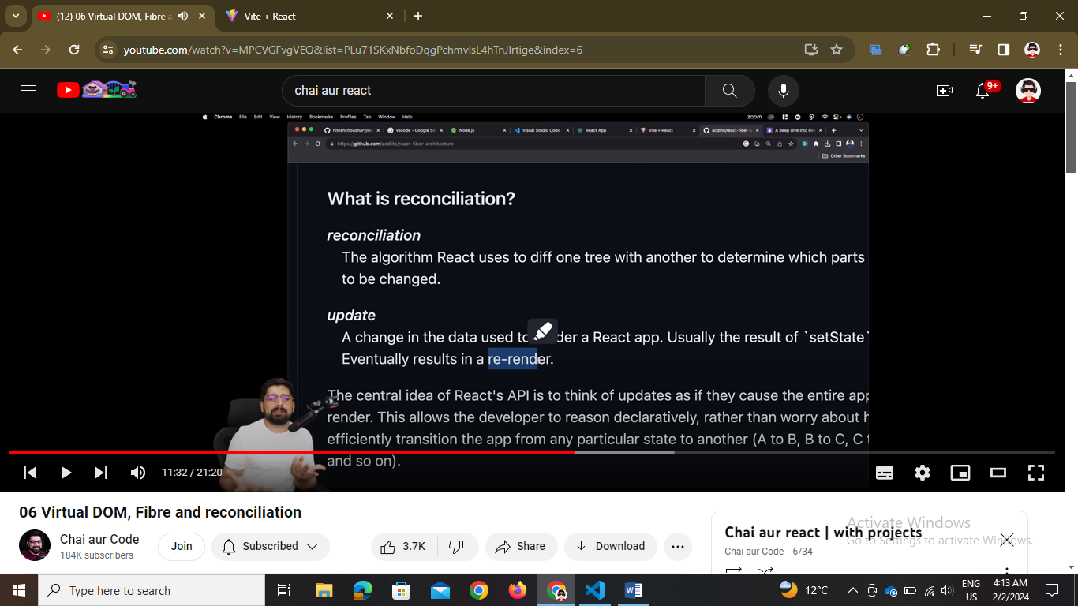

// reconciliation algo means comparing two doms and rendering only the change between them that change is done by the useState hook

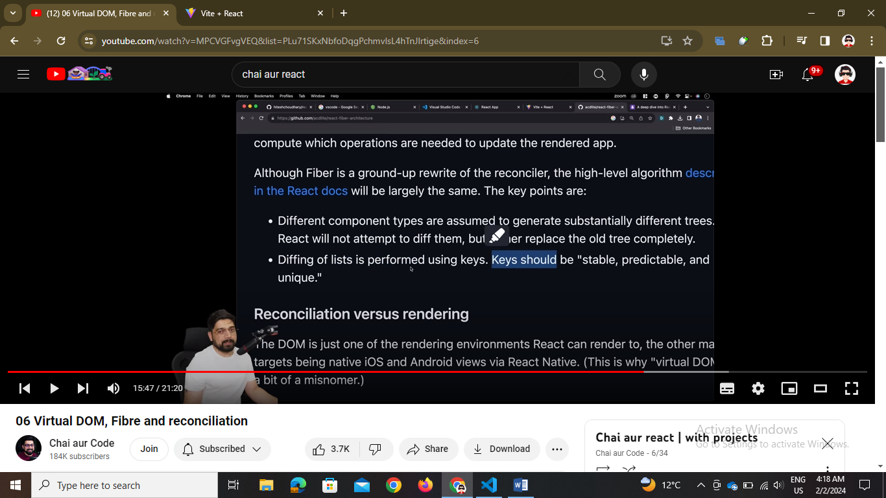

// keys are to be given in all list and array traversing 🡪 in fibre algo

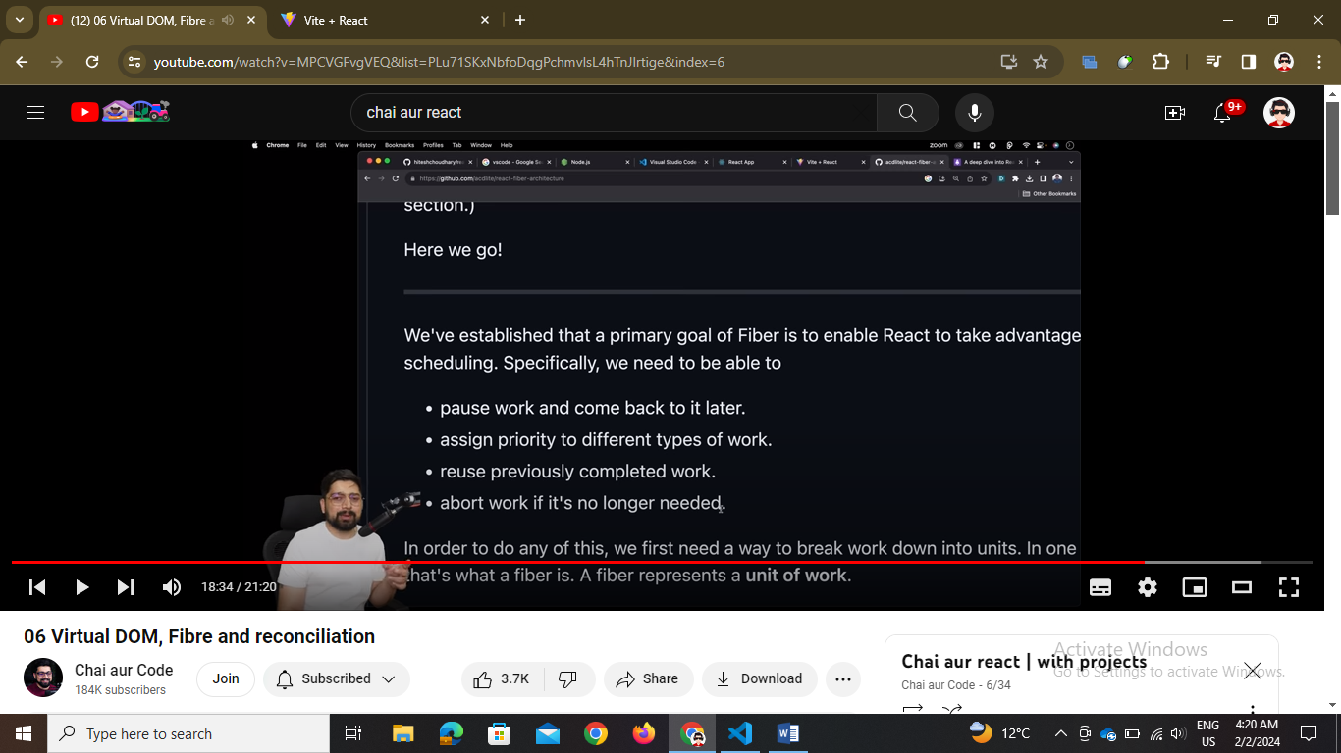

// 4 basic functions of fibre algo

Topics learnt in this - Reconciliation, fibre, virtual dom